Custom Connectors
Scenario
In this lab, you will build a custom connector for A Datum’s Risk Score API.
High-level lab objectives
- Build a custom connector
- Use this custom Connector in Copilot Studio
Exercise 1: Create a custom connector
Task 1: Create a new solution
- Navigate to https://make.powerapps.com/ and make sure you are in the Dev environment.
- Select Solutions and click + New solution. We are creating a new solution to keep the custom connector separate from the flow that uses it which is the current requirement of using a custom connector.
- Enter Builder Risk Service for Display name, select Relecloud for Publisher, and click Create.
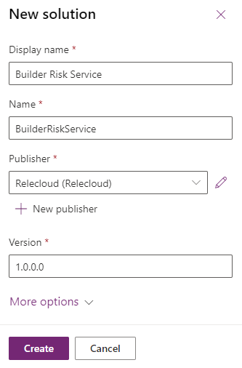
Task 2: Create custom connector
- Click + New and select Automation | Custom connector.
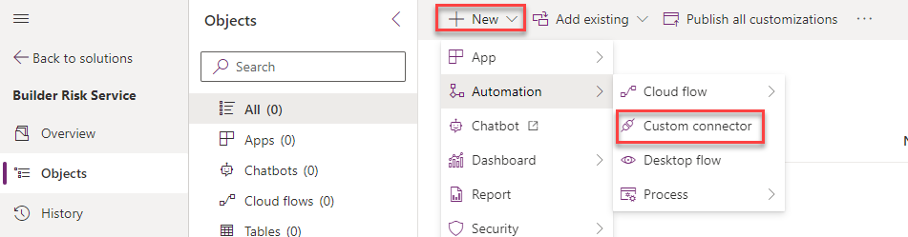
- Enter Builder Risk Service for Connector Name.
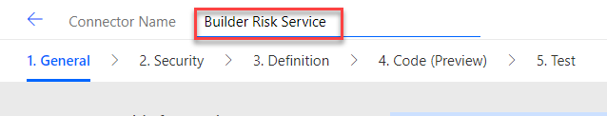
- Enter Service for evaluating builder risk for Description, enter adatumbuilderrisktest.azurewebsites.net for Host, and click Create connector.
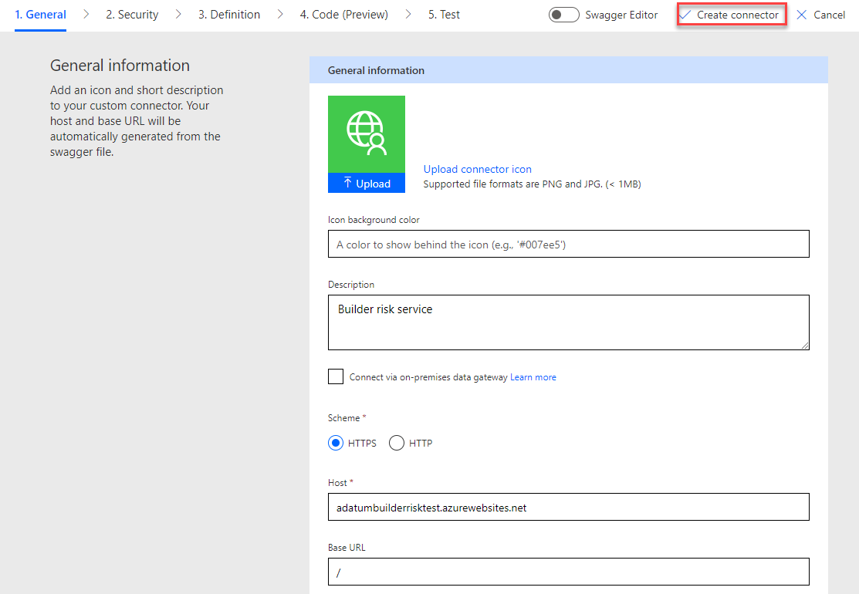
Task 3: Import Open API
- Navigate to https://adatumbuilderrisktest.azurewebsites.net/
- Click Download Logo and save the logo on your machine.
- Click on the API Key link.
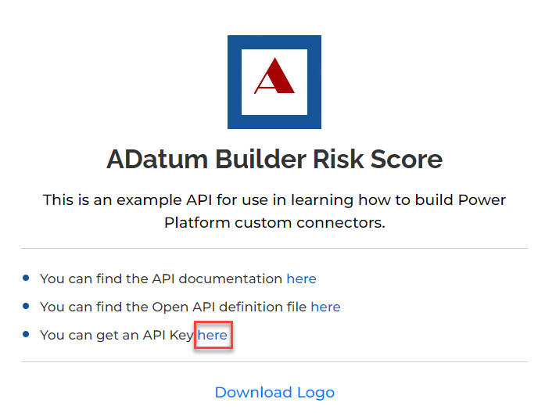
- Copy the API Key and save it on a notepad.
- Click Return to home.
- Click on the API documentation link.
- Review the documentation.
- Close the documentation browser tab or window, after you finish reviewing.
- Click on the Open API definition file link.
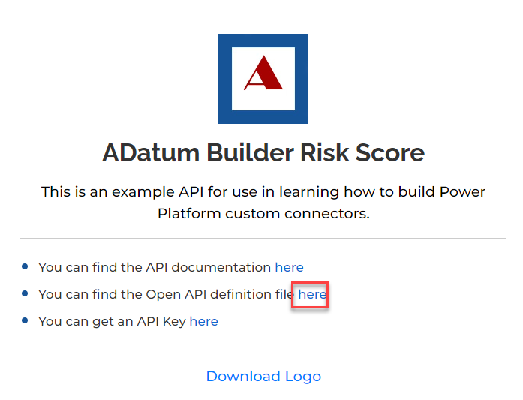
- On your keyboard press CTRL + S and select Save. Now the file is saved on your machine.
- Navigate to https://make.powerautomate.com/ and make sure you are in the Dev environment.
- Click More and select Discover all.
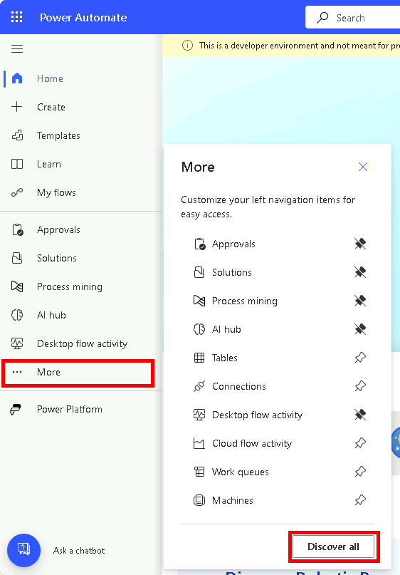
- Scroll down and select Custom connectors under data.
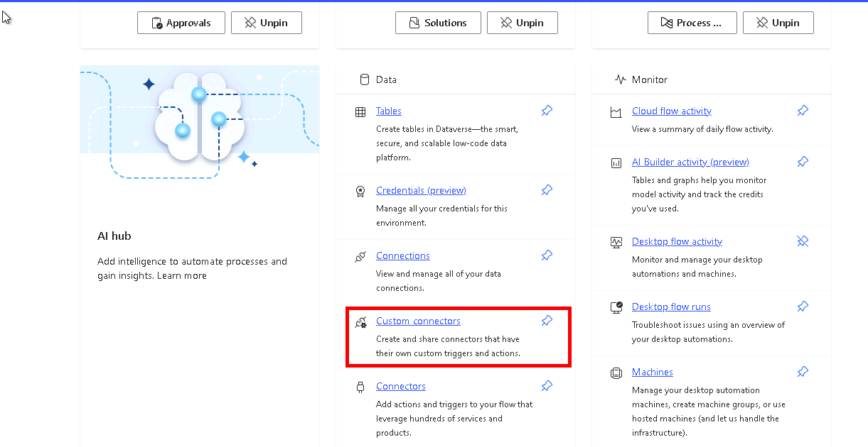
- Click on the … more actions button of the Builder Risk Service custom connector and select Update from OpenAPI file.
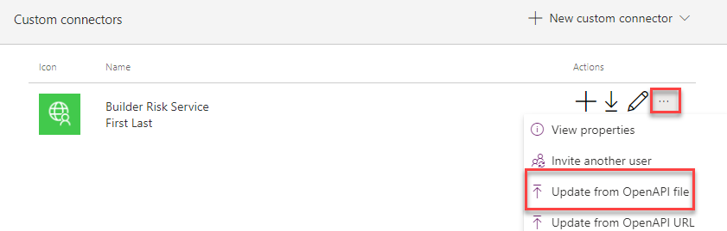
- Click Import.
- Select the swagger.json file you saved to your machine and click Open.
- Click Continue.
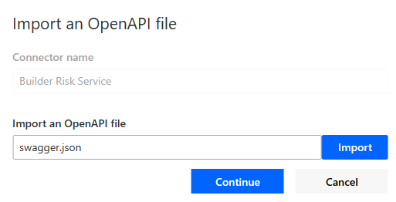
- Click Upload under the logo.
- Select the logo you downloaded and click Open.
- Enter Service for evaluating builder risk for Description, enter
adatumbuilderrisktest.azurewebsites.net for Host, and select Security from the breadcrumb navigation bar at the top of the screen.
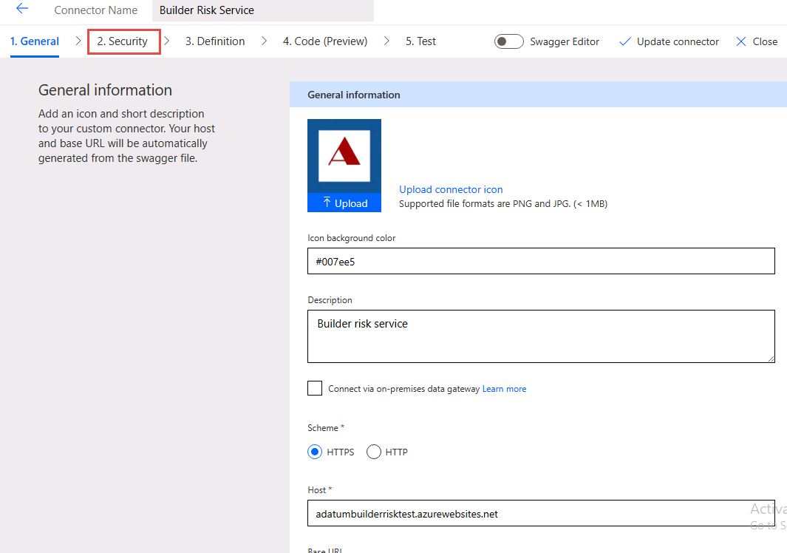
- Select Definition from the breadcrumb navigation bar at the top of the screen and see the operation imported.
- Turn on Swagger Editor.
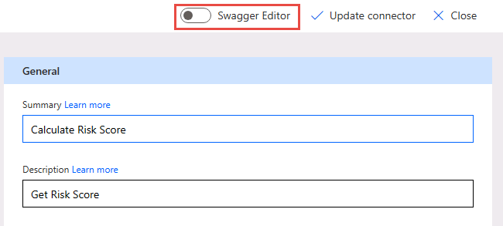
- Have a look at the Swagger Editor and then turn off the Swagger Editor.
- Select Update connector and wait for the connector to be updated.
- Do not navigate away from this page.
Task 4: Test connector
- Select Test from the breadcrumb navigation bar at the top of the screen and click + New connection.
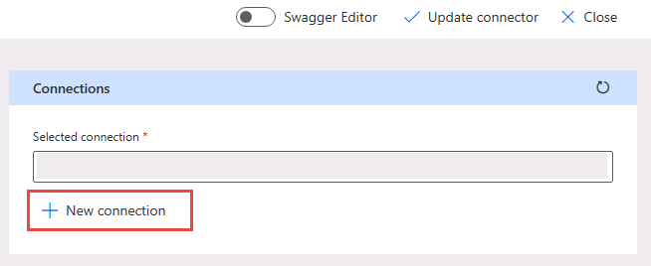
- Paste your API Key and click Create connection.
- Click the Refresh connections button, on the right. The connection you just created should be the Selected connection.
- Under CalcRiskScore, enter Contoso for builderName, 7165 Brock Lane Renton, WA 61795 U.S. for propertyAddress, JG7165 for loanNumber, 645000 for loanAmount, 500000 for creditAvailable, 100000 for drawAmount, and click Test operation.
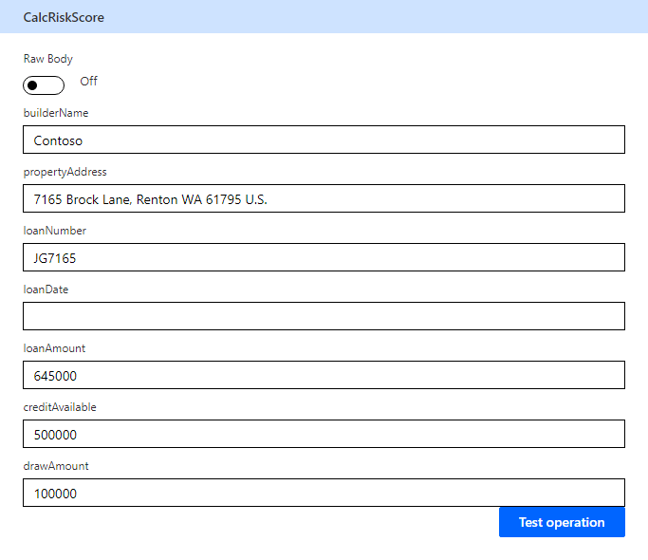
- The test should run successfully, and you should receive a score and a reason.
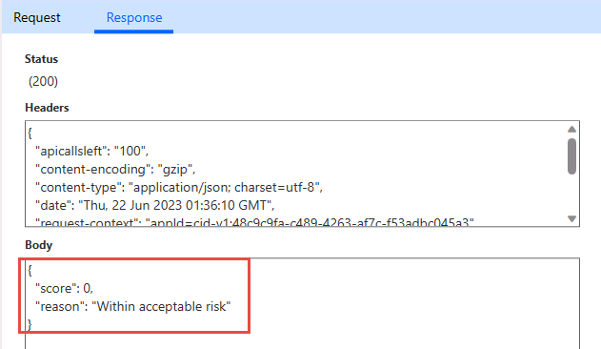
- Click Close to return to the list of Custom connectors.

Exercise 2: Use the custom Connector in Copilot Studio
Create new agent, give name and go to settings and update the solution
Add this connector as tool in copilot studio new experience

create a instruction for Agent Validate the Risk Score for the loan Amount request and get builderName, propertyAddress, loanNumber, loanAmount, creditAvailable and drawAmount from user
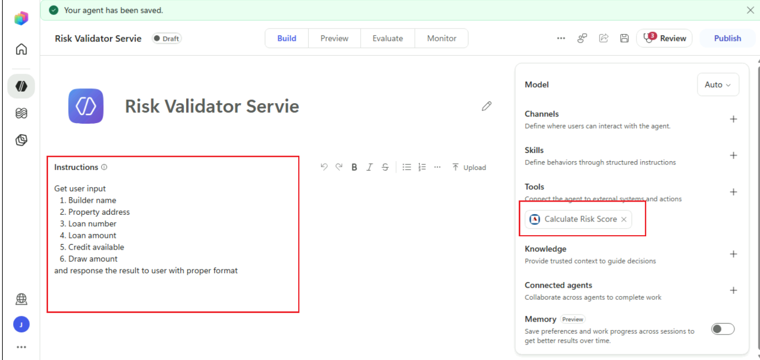

Output
Go to Preview


